Odd Semester (2021)



**BINUS UNIVERSITY**

**BINUS INTERNATIONAL**

**Assignment Cover Letter**

**(Individual Work****)**

|  |  |  |  |  |  |  |  |  |
| --- | --- | --- | --- | --- | --- | --- | --- | --- |
|  | | | | |  | |  | |
| **Student Information**: **Surname** | | | | | **Given Names**  **Muhamad Aria Armada** | | **Student ID Number**  **2101718500** | |
|  | | **Djojosugito** |  | |
|  |  |
| **Course Code** | **: COMP6502** |  |  | | **Course Name** | | **: Introduction to Programming** | |
| **Class** | **: L1BC-BLK** |  |  | | **Name of Lecturer(s)** | | **:** 1. Jude Joseph Lamug Martinez | |
|  |  |  |  | |  | | 2. Minaldi Loeis | |
| **Major** | **: CS** |  |  | |  | |  | |
| **Title of Assignment**  (if any) | : Zombies Game | |  |  | |  | |  | |
| **Type of Assignment**    **Submission Pattern** | **: Final Project** |  |  | |  | |  | |
| **Due Date** | **: 6-11-2017** |  |  | | **Submission Date** | | **: 6-11-2017** | |

The assignment should meet the below requirements.

1. Assignment (hard copy) is required to be submitted on clean paper, and (soft copy) as per lecturer’s instructions.
2. Soft copy assignment also requires the signed (hardcopy) submission of this form, which automatically validates the softcopy submission.
3. The above information is complete and legible.
4. Compiled pages are firmly stapled.
5. Assignment has been copied (soft copy and hard copy) for each student ahead of the submission.

# Plagiarism/Cheating

Binus International seriously regards all forms of plagiarism, cheating and collusion as academic offenses which may result in severe penalties, including loss/drop of marks, course/class discontinuity and other possible penalties executed by the university. Please refer to the related course syllabus for further information.

# Declaration of Originality

By signing this assignment, I understand, accept and consent to Binus International terms and policy on plagiarism. Herewith I declare that the work contained in this assignment is my own work and has not been submitted for the use of assessment in another course or class, except where this has been notified and accepted in advance.

Signature of Student: (Name of Student)

1. Muhamad Aria Armada Djojosugito

**“Zombie Game”**

**Name :Muhamad Aria Armada Djojosugito**

**ID :2101718500**

1. **Description**

**The function of this program:**

This program is meant to help people to alleviate their boredom with a simple game to play on their Personal Computer.

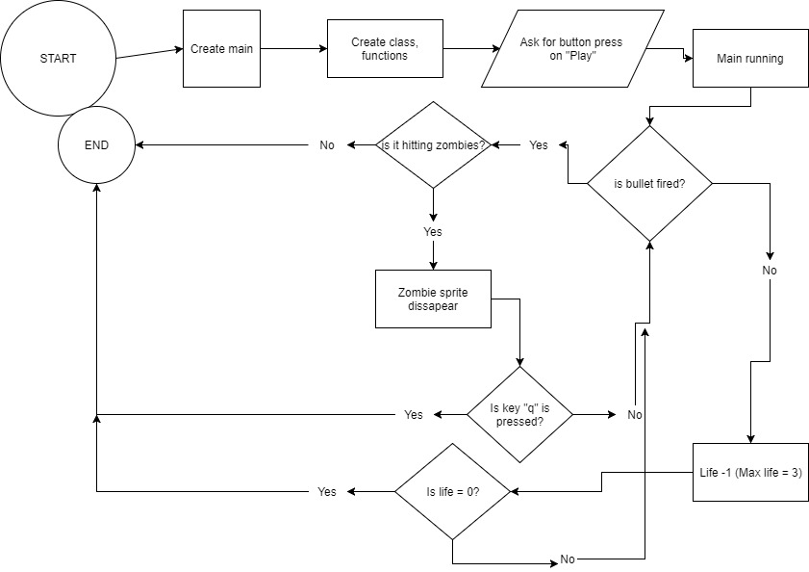

**II.b. Explanation of Each function**

**1.Main: ( *main.py* ):**

run_game():

1. Initialize pygame with *pygame.init()*
2. Declare *Settings()* which contains all initial settings for the game
3. Declare *bullets* and *zombies* as a *Group()* so they can be rendered multiple times
4. Declare *Screen* with variables from *Settings()* to render the pygame’s screen

**2.Settings: (*settings.py)*:**

Init_dynamic_set():

1. Setting variables that change throughout the game
2. Variables on this function: survivor’s speed, bullet’s speed, zombie’s speed

Increase_speed():

1. Setting increases in speed values and scores

**3.Game Functions: (*game_functions.py*):**

check_events():

1. Works to establish event variable so that it can respond to keypresses

check_play_button():

1. Checking whether or not the play button clicked if game inactive

Get_number_zombies_x():

1. Calculate how many zombies can be put on the screen window

Get_number_rows():

1. Calculate how many rows of zombies to be fitted on the screen window

Create_zombie():

1. Rendering the zombie itself

Create_horde():

1. Using previously defined function,get_number_zombies_x and get_number_rows to create the horde of zombies on the screen

Check_horde_edges():

1. Using check_edges function in zombie.py to change its direction

Change_horde_direction():

1. Change the horde direction while at the same time accelerate the zombie sprites

Survivor_hit():

1. Establish what would happen if the survivor is hit by zombie and his life hits 0

Check_zombies_bottom():

1. Defining what would happen if the zombies hit the bottom part of the screen

Check_high_score():

1. Used for comparing the score to the high score

Update_screen():

1. Render the screen, background, survivor blit, zombies, and the bullet while the game is active

Check_keydown_events():

1. Checking any key push input from the hardware and events appropriate for the input

Check_keyup_events():

1. Responding to any key that has been released from being pushed

Update_bullets():

1. Update any bullets that has been fired

Check_bulet_zombies_collition():

1. Functions as a way to establish collition events and its appropriate response

Fire_bullet():

1. Firing the bullet when it is available from allowed amount set in settings()

Update_zombie():

1. Update zombies against any collition

**3.Zombie: (***zombie.py*):

Blitme():

1. Setting image loaded as zombie to be blit on to the screen

Update():

1. Update its speed and direction as per changes in x

Check_edges()

1. Check whether or not the zombie sprite horde as a whole hit the edges of the screen

**4.Survivor:** (*survivor.py*):

Update():

1. Update its position from any events happened with key push

Blitme():

1. Draw the survivor at its current location

Center_surv():

1. Establish its center

**5.Bullet: (***bullet.py*):

Update():

1. Setting the bullet flight speed

Draw_bullet():

1. Draw the bullet onto the screen

**6.Button: (***button.py*):

Prep_msg():

1. Prepare the button with font render, rect image and its placement at the center

Draw_button():

1. Draw the button onto the screen

Source Code:

1.Main.py

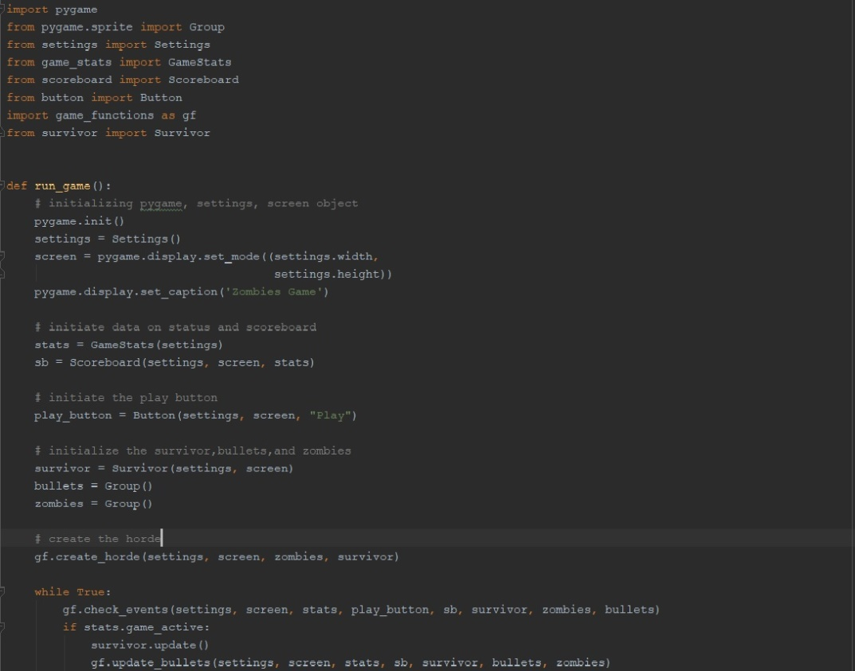

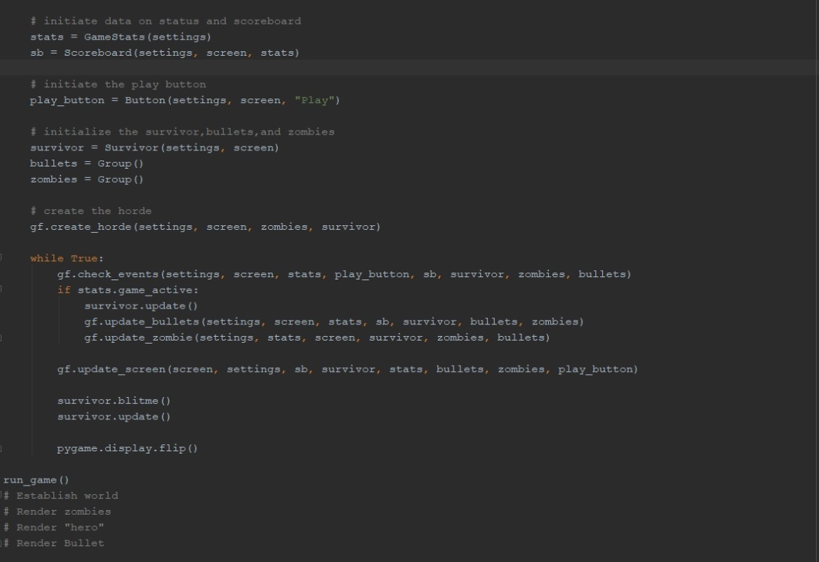

**2.settings.py**

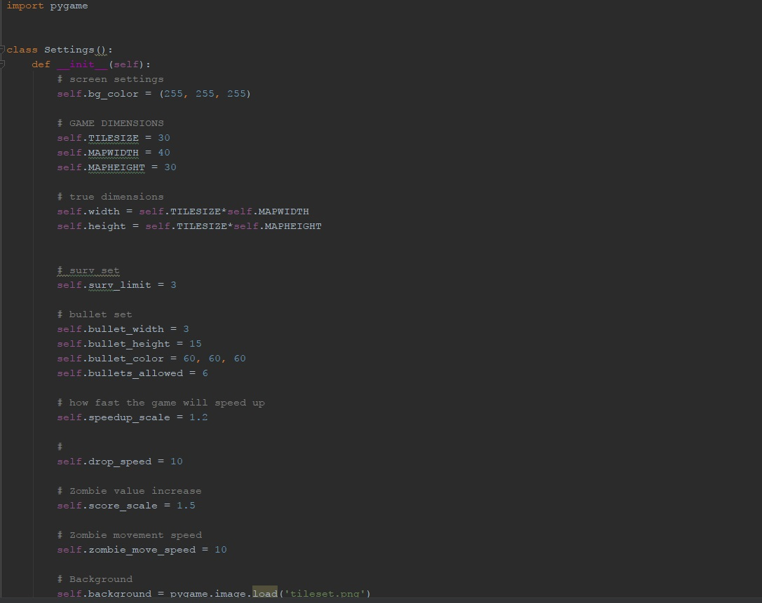

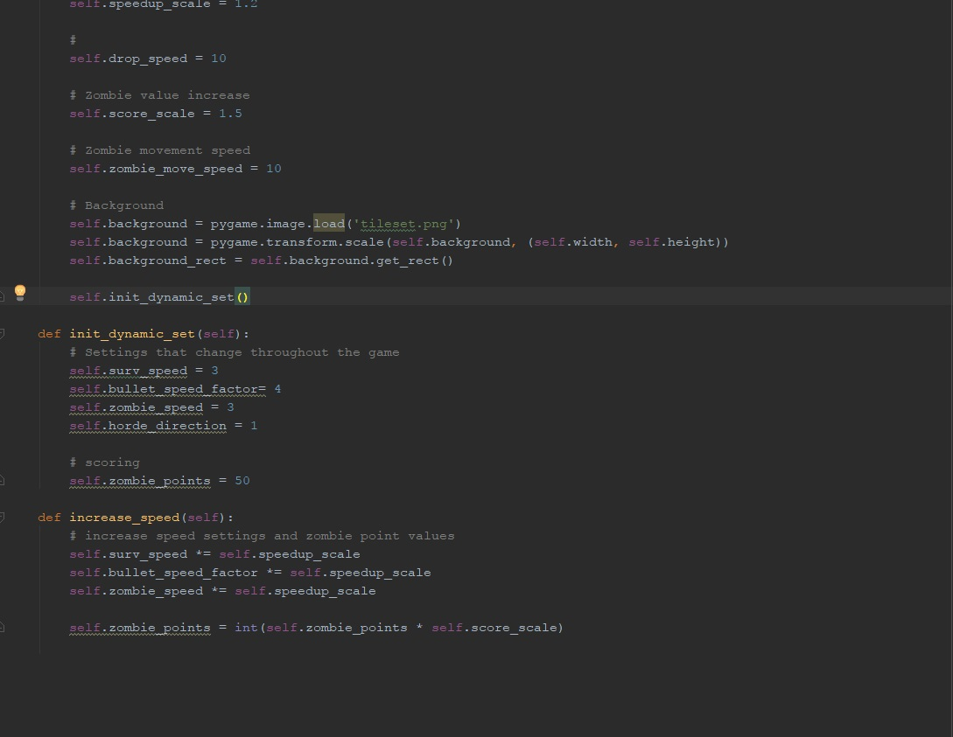

**3.game_functions.py**

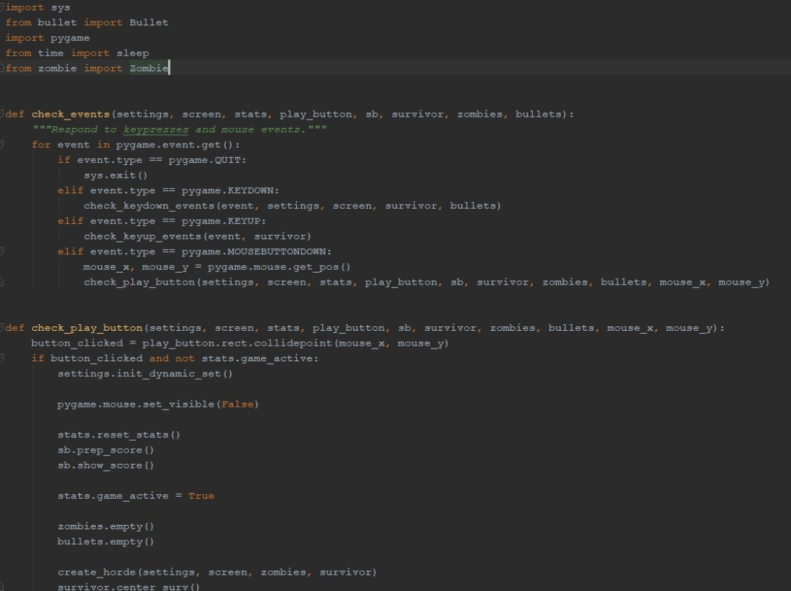

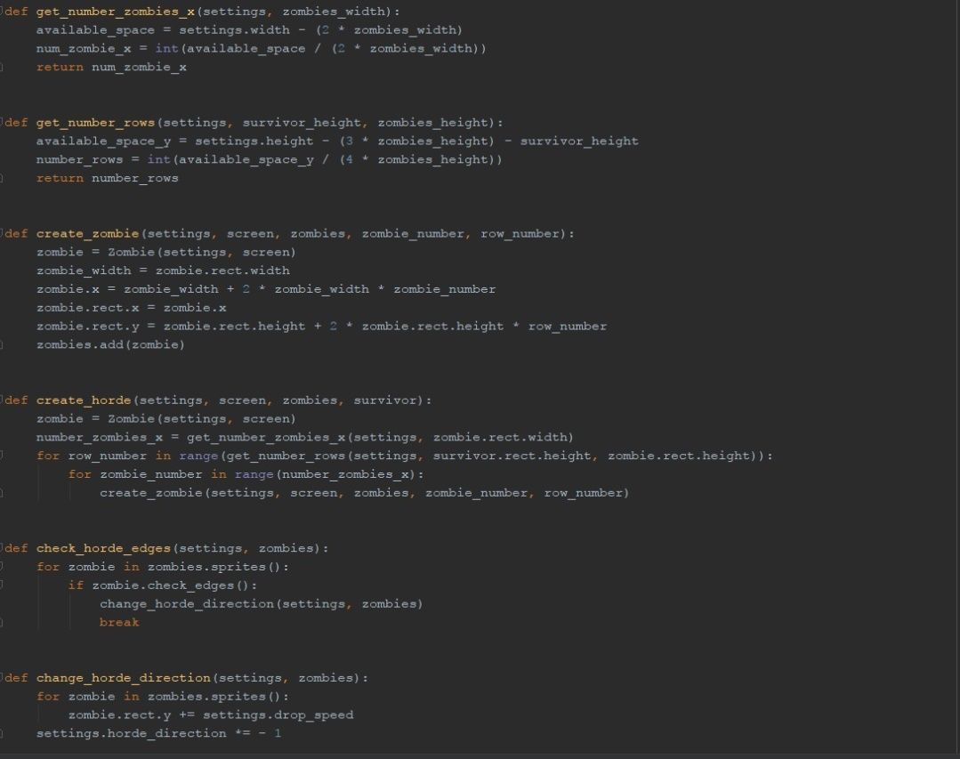

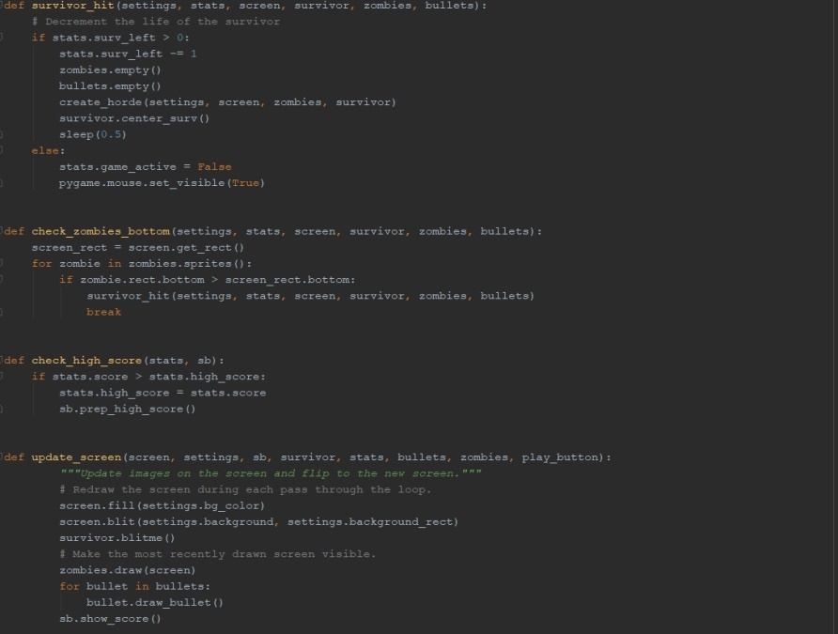

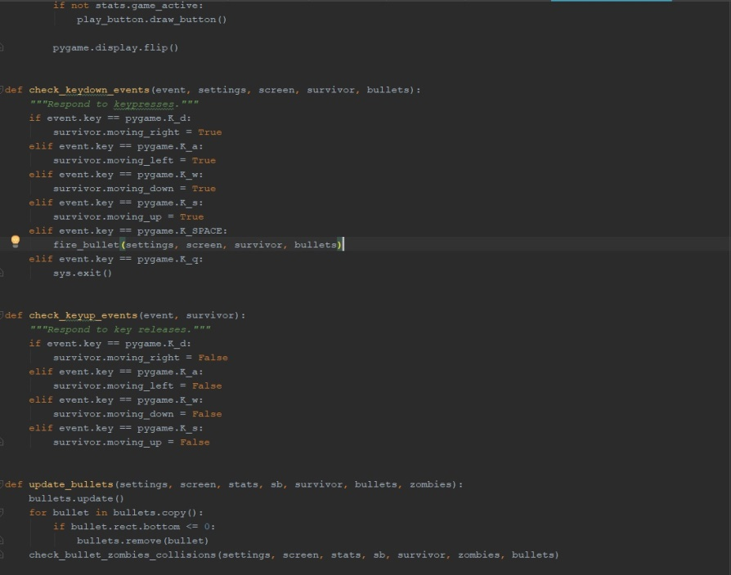

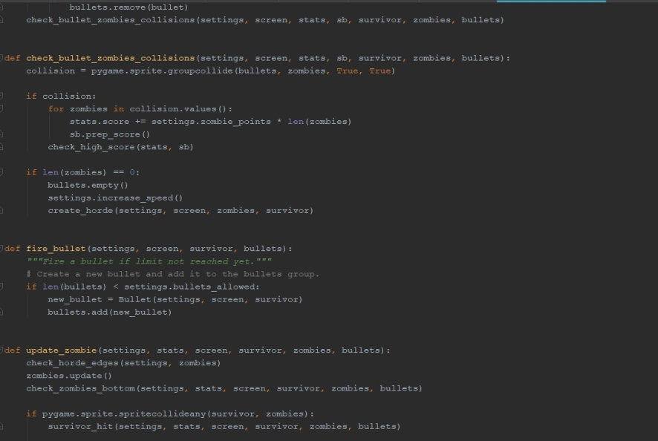

**4.survivor.py**

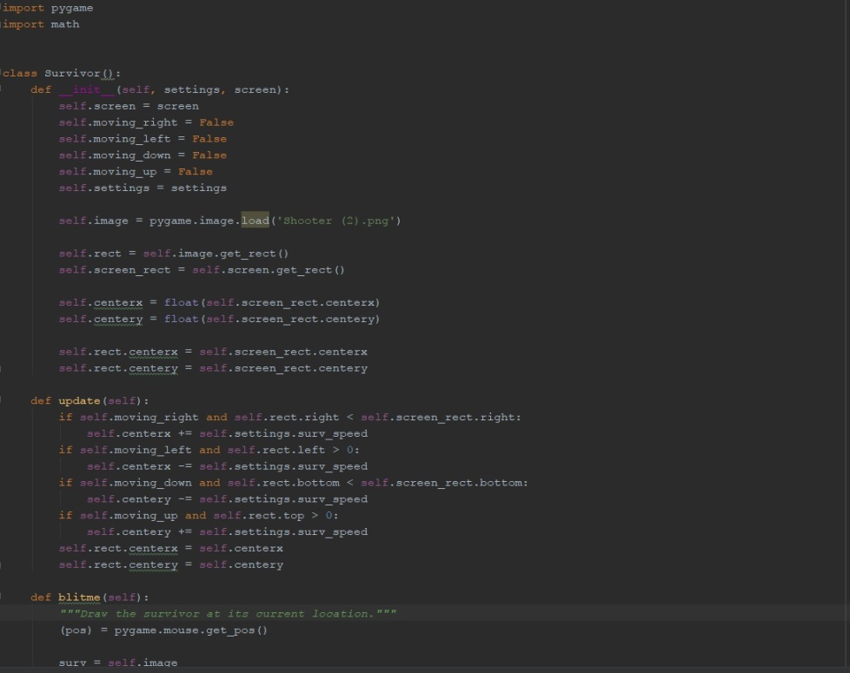

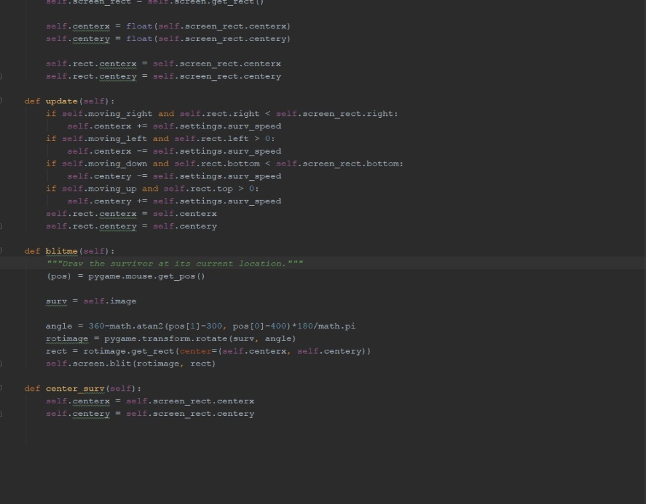

**5.zombie.py**

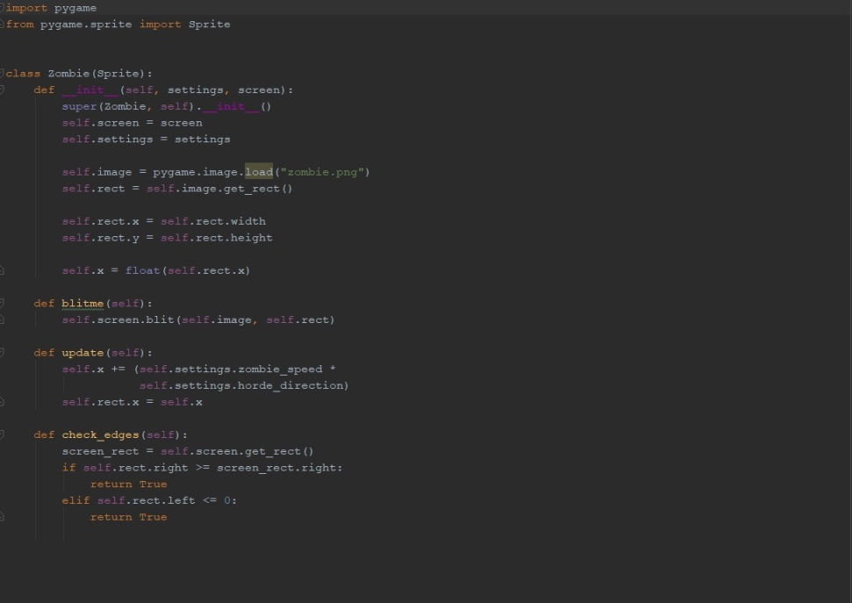

**6.bullet.py**

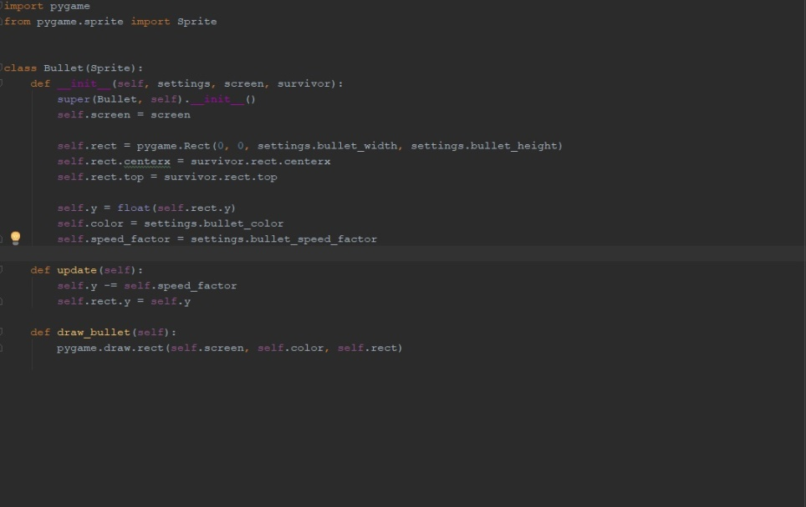

**7.button.py**

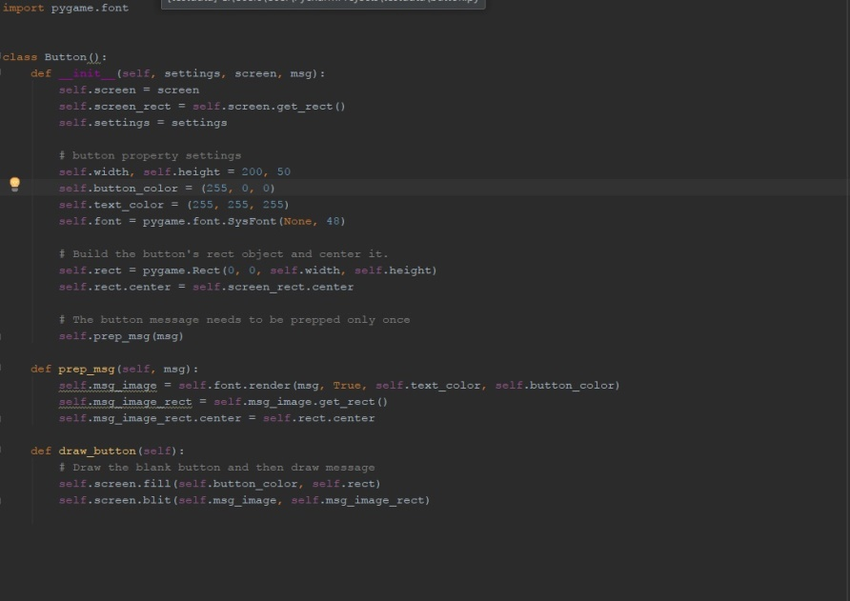

**UML Diagram:**

|  |
| --- |
| Main |
| # |
|  |
|  |
| + run_game():  +Settings() |
| +GameStats(data(Settings)) |
| +game_functions(data(Settings)) |

|  |
| --- |
| Survivor |
| **-** |
| +__init__(a: self, data(settings), data(screen)) |
| +update(self) |
| +blitme(self)  +center_surv(self) |

|  |
| --- |
| Zombie |
| +__init__(a: self, data(settings), data(screen)) |
| +update(self) |
| +blitme(self)  +check_edges(self) |